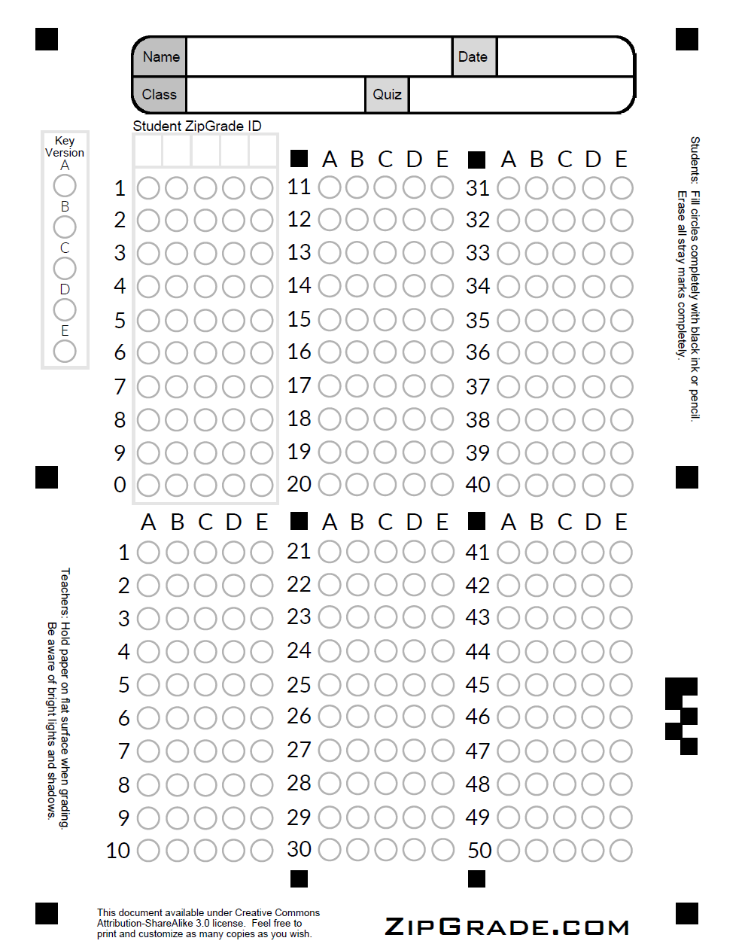

COMP 3522
OBJECT ORIENTED PROGRAMMING 2

Final Exam
December 2024

Full Name
Signature
Student ID
Set

Instructions:
- This is a closed-book exam. Two cheat sheets are allowed.
- Headphones/ear buds are OK.
- This midterm is 90 minutes long.
- Add the answers for T/F and MCQ questions to the Answer Sheet in Page 1.
- The exam will include the following components:
  - True/False Questions: 5 questions, each worth 1 mark, totaling 5 marks.
  - Multiple-Choice Questions: 15 questions, each worth 2 marks, totaling 30 marks.
  - Draw a UML Diagram: 1 question, worth 4 marks.
  - What is the Output: 1 question, worth 4 marks.
  - Guided Coding: 1 question with two parts, worth 8 marks.

Total Marks: 51, scaled to account for 30% of the course grade.

- Good luck. You’re awesome, you’ve got this.

Final grade:

True/False Questions

Question 1
The @staticmethod decorator allows a method to access class-level variables.
FALSE

Question 2
The Dependency Inversion Principle (DIP) suggests that both high-level and low-level modules should depend on abstractions, not concrete implementations, which promotes loose coupling and flexibility in the codebase
TRUE

Question 3
Decorator and Proxy have similar structures, but very different intents.
TRUE
Use the following code to answer the following two questions
def safe_divide(x, y):
try:
return x / y
except ZeroDivisionError:
return None # Or you might want to raise a custom exception
import unittest
class TestExceptionHandling(unittest.TestCase):
def test_divide_by_zero(self):
with self.assertRaises(ZeroDivisionError):
safe_divide(5, 0)
def test_safe_division(self):
result = safe_divide(10, 2)
self.assertIsNone(result) # Assuming you return None on error
# Run the tests
unittest.main()

Question 4
The test_divide_by_zero unit test will pass
FALSE

Question 5
The test_safe_division unit test will pass
FALSE

Multiple Choice Questions
Choose the best answer for the following questions.

Question 6
What is the typical role of the base handler class in the Chain of Responsibility pattern?
A. To define a subscription mechanism for request notifications.
B. To forward requests to the next handler by default.
C. To act as a factory for creating handlers.
D. To store the client’s request data persistently.

Question 7
What is a common drawback of the Strategy pattern?
A. It introduces tight coupling between the context and strategy objects.
B. It requires the client to know and select the appropriate strategy.
C. It makes it difficult to extend the behavior of an object.
D. It enforces a static behavior for all context objects.

Question 8
How does the Decorator pattern fundamentally differ from the Proxy pattern in terms of their structure and purpose?
A. Proxy is based on inheritance, while Decorator relies on composition.
B. Decorator manages the lifecycle of its service object, while Proxy does not.
C. Proxy typically controls access or permissions, while Decorator enhances functionality without modifying the interface.
D. Both Decorator and Proxy are interchangeable patterns used for encapsulating objects.

Question 9
How does the Mediator pattern differ from the Observer pattern in its primary goal?
A. Mediator focuses on dynamic, one-way communication, while Observer centralizes communication among objects.
B. Mediator aims to reduce mutual dependencies between components, while Observer establishes dynamic one-way communication.
C. Mediator uses composition, while Observer relies on inheritance
D. Mediator always acts as a publisher, whereas Observer requires no publisher.

Question 10
What is a key difference between the State and Strategy patterns?
A. State restricts dependencies between concrete implementations, while Strategy allows interdependencies.
B. Strategy alters behavior by inheritance, while State alters behavior through composition.
C. State allows transitions between states to alter the context’s state, while Strategy isolates different behaviors.
D. State and Strategy are functionally identical and differ only in naming conventions.

Question 11
How does the Facade pattern differ from the Mediator pattern in its relationship to subsystems?
A. Facade allows direct communication between components, while Mediator does not.
B. Mediator defines a simplified interface to a subsystem, while Facade eliminates subsystem dependencies.
C. Facade does not introduce new functionality to a subsystem, while Mediator coordinates component interactions
D. Facade increases coupling between subsystems, while Mediator decreases coupling..

Question 12
What does the time.time() function return?
- The current time in milliseconds since the epoch.
- The current time in microseconds since the epoch.
- The current time in seconds since the epoch.
- The current time in nanoseconds since the epoch.

Question 13
What is the output of the following code?
class SomeIterator:
def __init__(self, limit):
self.current = limit
def __iter__(self):
return self
def __next__(self):
if self.current >= 1:
result = self.current**2
self.current -= 2
return result
else:
raise StopIteration
for x in SomeIterator(5):
print(x)
Options:

Option A.
25
16
9
4
1
Option B.
25
9
1
Option C.
1
4
9
16
25
Option D.
1
9
25

Question 14
What is the output of the following code?

class Coffee:
def cost(self):
return 5
class MilkDecorator:
def __init__(self, coffee):
self._coffee = coffee
def cost(self):
return self._coffee.cost() + 2
class SugarDecorator:
def __init__(self, coffee):
self._coffee = coffee
def cost(self):
return self._coffee.cost() + 1
class CaramelDecorator:
def __init__(self, coffee):
self._coffee = coffee
def cost(self):
return self._coffee.cost() + 3
# Client code
coffee_with_all_decorators = CaramelDecorator(SugarDecorator(MilkDecorator(Coffee())))
print(coffee_with_all_decorators.cost())
print(CaramelDecorator(CaramelDecorator(SugarDecorator(MilkDecorator(Coffee())))).cost())
Options:
A. 10, 13
B. 11, 14
C. 11, 11
D. 8, 11

Question 15
Which of the following UMLs is the actual representation of the following code?
from abc import ABC, abstractmethod
class ProxyInterface(ABC):
@abstractmethod
def request(self):
pass
class RealSubject(ProxyInterface):
def request(self):
return "Handling request by RealSubject"
class CachedProxy(ProxyInterface):
def __init__(self, subject):
self._subject = subject
self._cached_response = None
def request(self):
if not self._cached_response:
print("[CachedProxy] Cache is empty. Fetching from RealSubject...")
self._cached_response = self._subject.request()
else:
print("[CachedProxy] Returning cached response.")
return self._cached_response
class ProtectionProxy(ProxyInterface):
def __init__(self, subject, user_role):
self._subject = subject
self._user_role = user_role
def request(self):
print(
f"[ProtectionProxy] Verifying access for role: {self._user_role}"
)
if self._user_role == "Admin":
return self._subject.request()
else:
return "[ProtectionProxy] Access Denied."
class LoggingProxy(ProxyInterface):
def __init__(self, subject):
self._subject = subject
def request(self):
print("[LoggingProxy] Logging the request.")
return self._subject.request()
# Client code
real_subject = RealSubject()
print("Using Cached Proxy:")
cached_proxy = CachedProxy(real_subject)
print(cached_proxy.request()) # First call, fetches from RealSubject
print(cached_proxy.request()) # Second call, returns cached response
print("\nUsing Protection Proxy:")
admin_proxy = ProtectionProxy(real_subject, "Admin")
user_proxy = ProtectionProxy(real_subject, "User")
print(admin_proxy.request()) # Access granted for Admin
print(user_proxy.request()) # Access denied for User
print("\nUsing Logging Proxy:")
logging_proxy = LoggingProxy(real_subject)
print(logging_proxy.request()) # Logs the request and delegates to RealSubject
Options:
A. Option A
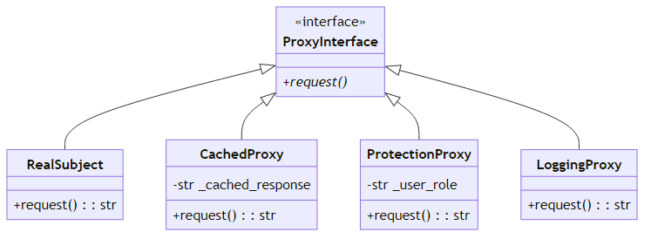
B. Option B
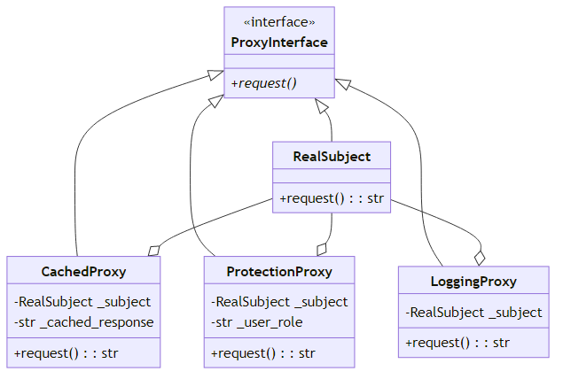
C. Option C
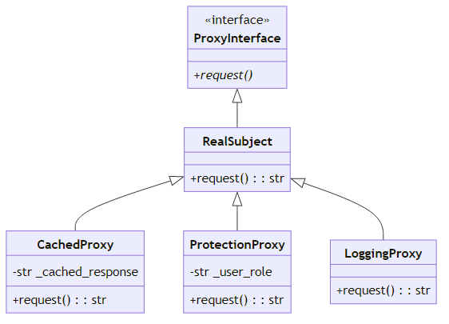

Question 16
Which of the following implementations is faithful to the following UML diagram?
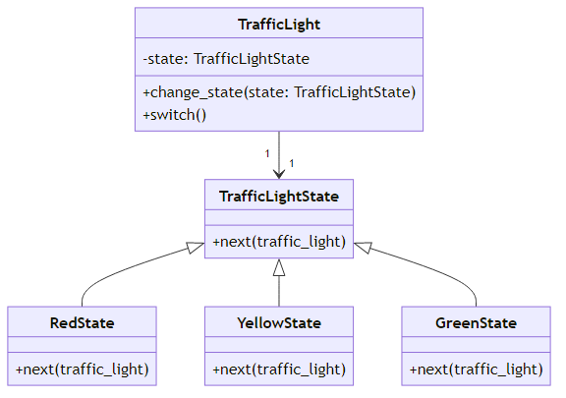
Options:
Option A:
from abc import ABC, abstractmethod
class TrafficLightState(ABC):
@abstractmethod
def next(self, traffic_light):
pass
class RedState(TrafficLightState):
def next(self, traffic_light):
print("Red light -> Switching to green.")
traffic_light.change_state(GreenState())
class YellowState(TrafficLightState):
def next(self, traffic_light):
print("Yellow light -> Switching to red.")
self.next_state = RedState()
traffic_light.change_state(self.next_state)
class GreenState(TrafficLightState):
def next(self, traffic_light):
print("Green light -> Switching to yellow.")
self.next_state = YellowState()
traffic_light.change_state(self.next_state)
class TrafficLight:
def __init__(self):
self.state = RedState()
def change_state(self, state):
self.state = state
def switch(self):
self.state.next(self)
Option B:
from abc import ABC, abstractmethod
class TrafficLightState(ABC):
@abstractmethod
def next(self, traffic_light):
pass
class RedState(TrafficLightState):
def next(self, traffic_light):
print("Red light -> Switching to green.")
traffic_light.change_state(GreenState())
class YellowState(TrafficLightState):
def next(self, traffic_light):
print("Yellow light -> Switching to red.")
traffic_light.change_state(RedState())
class GreenState(TrafficLightState):
def next(self, traffic_light):
print("Green light -> Switching to yellow.")
traffic_light.change_state(YellowState())
class TrafficLight:
def __init__(self):
self.state = RedState()
def change_state(self, state):
self.state = state
def switch(self):
self.state.next(self)

Question 17
What is the total time taken to run the following code?
import asyncio
import time
class Subject:
def __init__(self):
self._observers = []
self.news_data = {
"sports": ["Game 1 Highlights", "Player Transfers", "Match Schedules"],
"tech": ["New AI Breakthrough", "Latest Gadgets", "Tech Company Earnings"],
"politics": ["Election Results", "Policy Changes", "Government Scandals"],
}
def attach(self, observer):
if observer not in self._observers:
self._observers.append(observer)
def detach(self, observer):
if observer in self._observers:
self._observers.remove(observer)
async def notify(self, category):
for observer in self._observers:
await observer.update(self, category)
async def get_latest_news(self, category):
# Simulate a slight delay in fetching news data
await asyncio.sleep(0.1)
return self.news_data.get(category)
class Observer:
async def update(self, subject, category):
# Simulate time to receive the category update
await asyncio.sleep(0.5)
print(f"Observer received category update: {category}")
news_items = await subject.get_latest_news(category)
print(f"Fetching news in category '{category}': {news_items}")
async def main():
start_time = time.perf_counter()
subject = Subject()
observer_a = Observer()
observer_b = Observer()
observer_c = Observer()
subject.attach(observer_a)
subject.attach(observer_b)
task_notify1 = asyncio.create_task(subject.notify("sports"))
task_notify2 = asyncio.create_task(subject.notify("tech"))
await task_notify1;
await task_notify2;
await subject.notify("politics")
end_time = time.perf_counter()
print(f"Total time: {end_time - start_time:.2f} seconds")
if __name__ == "__main__":
asyncio.run(main())
Options:
A. 1.2 seconds
B. 2.4 seconds
C. 3.6 seconds
D. 4.8 seconds

Questions 18
What is the primary purpose of the Builder Design Pattern?
A. To reduce the number of subclasses needed for different configurations.
B. To make object creation faster.
C. To eliminate the need for any constructor and use setters instead.
D. To directly instantiate complex objects with default values.

Questions 19
In the Builder Pattern implementation, what is the role of the Director class?
A. To define the blueprint of the product being built.
B. To orchestrate the construction steps for different configurations.
D. To implement the methods for building specific parts of the product.
D. To instantiate the final object directly.

Questions 20
What is a disadvantage of using the Builder Pattern?
A. Reduced flexibility in object creation.
B. Increased complexity due to additional classes like the builder and director.
C. The need to rewrite the entire product class.
D. Dependency on subclass hierarchies for different configurations.

Draw a UML
Complete the following UML diagram of the Builder design pattern. Do not include the methods in the diagram. Only include the class names and relationships.
Your Answer:
You may use the following blocks. You only need to connect them using the proper relationships.
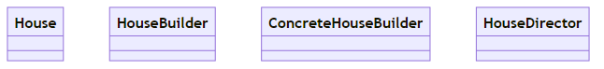

You may also use the follownig example that uses the Builder Design Pattern:
class House:
def __init__(self):
self.walls = None
self.roof = None
self.floor = None
self.door = None
self.windows = None
self.backyard = None
self.heating_system = None
self.plumbing = None
self.electrical_wiring = None
def __str__(self):
return (f"House: walls={self.walls}, roof={self.roof}, floor={self.floor}, "
f"door={self.door}, windows={self.windows}, backyard={self.backyard}, "
f"heating_system={self.heating_system}, plumbing={self.plumbing}, "
f"electrical_wiring={self.electrical_wiring}")
class HouseBuilder:
def build_walls(self):
pass
def build_roof(self):
pass
def build_floor(self):
pass
def install_door(self):
pass
def fit_windows(self):
pass
def add_backyard(self):
pass
def add_heating_system(self):
pass
def add_plumbing(self):
pass
def add_electrical_wiring(self):
pass
def get_result(self):
pass
class ConcreteHouseBuilder(HouseBuilder):
def __init__(self):
self.house = House()
def build_walls(self):
self.house.walls = "Brick walls"
return self
def build_roof(self):
self.house.roof = "Tile roof"
return self
def build_floor(self):
self.house.floor = "Wooden floor"
return self
def install_door(self):
self.house.door = "Wooden door"
return self
def fit_windows(self):
self.house.windows = "Glass windows"
return self
def add_backyard(self):
self.house.backyard = "Small backyard"
return self
def add_heating_system(self):
self.house.heating_system = "Central heating system"
return self
def add_plumbing(self):
self.house.plumbing = "Modern plumbing"
return self
def add_electrical_wiring(self):
self.house.electrical_wiring = "Standard electrical wiring"
return self
def get_result(self):
return self.house
class HouseDirector:
def __init__(self, builder):
self.builder = builder
def construct_minimal_house(self):
return (self.builder
.build_walls()
.build_roof()
.build_floor()
.install_door()
.fit_windows()
.get_result())
def construct_luxury_house(self):
return (self.builder
.build_walls()
.build_roof()
.build_floor()
.install_door()
.fit_windows()
.add_backyard()
.add_heating_system()
.add_plumbing()
.add_electrical_wiring()
.get_result())
if __name__ == "__main__":
builder = ConcreteHouseBuilder()
director = HouseDirector(builder)
# Construct a minimal house
minimal_house = director.construct_minimal_house()
print("Minimal House:")
print(minimal_house)
# Construct a luxury house
luxury_house = director.construct_luxury_house()
print("\nLuxury House:")
print(luxury_house)
Solution:
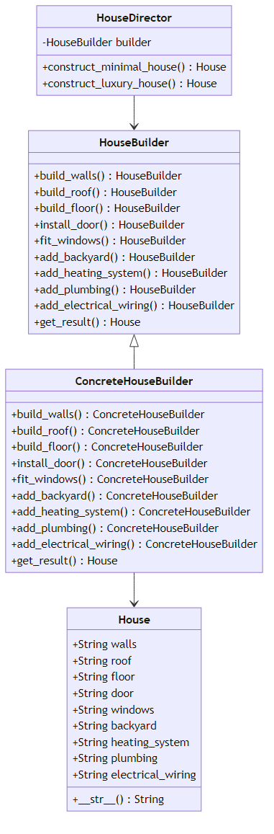

What is the output

Question
What is the output of the following code? Only fill the following boxes with the output.
class Order:
def __init__(self, items, total_amount, payment_status, shipping_status):
self.items = items
self.total_amount = total_amount
self.payment_status = payment_status
self.shipping_status = shipping_status
class OrderHandler:
def __init__(self, next_handler=None):
self.next_handler = next_handler
def handle_order(self, order):
if self.next_handler:
return self.next_handler.handle_order(order)
class ValidationHandler(OrderHandler):
def handle_order(self, order):
if order.items and order.total_amount > 0:
print("ValidationHandler: Order is valid.")
super().handle_order(order)
else:
print("ValidationHandler: Order is invalid and cannot proceed.")
class AuthorizationHandler(OrderHandler):
def handle_order(self, order):
if order.payment_status == "authorized":
print("AuthorizationHandler: Payment is authorized.")
super().handle_order(order)
else:
print("AuthorizationHandler: Payment not authorized. Order cannot proceed.")
class DiscountHandler(OrderHandler):
def handle_order(self, order):
if order.total_amount > 1000:
discount = order.total_amount * 0.1
order.total_amount -= discount
print(
f"DiscountHandler: Applied discount of ${discount:.2f}. New total is ${order.total_amount:.2f}.")
else:
print("DiscountHandler: No discount applied.")
super().handle_order(order)
class PackingHandler(OrderHandler):
def handle_order(self, order):
if len(order.items) > 5:
print("PackingHandler: Bulk order detected. Extra care in packing.")
else:
print("PackingHandler: Packing items for shipping.")
super().handle_order(order)
class ShippingHandler(OrderHandler):
def handle_order(self, order):
if order.shipping_status == "pending":
order.shipping_status = "shipped"
print("ShippingHandler: Order has been shipped.")
else:
print("ShippingHandler: Order already shipped or invalid shipping status.")
# Creating the chain of responsibility
shipping_handler = ShippingHandler()
packing_handler = PackingHandler(shipping_handler)
discount_handler = DiscountHandler(packing_handler)
authorization_handler = AuthorizationHandler(discount_handler)
validation_handler = ValidationHandler(authorization_handler)
# Example order
order = Order(
items=["Laptop", "Phone", "Tablet", "Mouse", "Keyboard", "Monitor"],
total_amount=2000,
payment_status="authorized",
shipping_status="pending"
)
# Start the chain with validation
validation_handler.handle_order(order)
Your Answer:
A partial output is provide to you. Complete it by filling the blank boxes.
ValidationHandler: Applied discount of $200.00. New total is $1800.00.
AuthorizationHandler: Applied discount of $200.00. New total is $1800.00.
DiscountHandler: Applied discount of $200.00. New total is $1800.00.
PackingHandler: Applied discount of $200.00. New total is $1800.00.
ShippingHandler: Applied discount of $200.00. New total is $1800.00.

ValidationHandler: Order is valid.
AuthorizationHandler: Payment is authorized.
DiscountHandler: Applied discount of $200.00. New total is $1800.00.
PackingHandler: Bulk order detected. Extra care in packing.
ShippingHandler: Order has been shipped.

Question - Guided Code Writing
Attached to this questions two code snippets, A and B (pages 20-24). The code snippets are related to the State design pattern. Code Snuppet A, demonstrates a character class that can move, run, jump, attack, stop, finish attacking, and land. Code Snippet B, demonstrates how the State design pattern is used to refactor Code Snippet A.

Part I - Complete a State Diagram
Use Code Snippet A and/or Code Snippet B to add the Attacking state to the following state diagram along with the transitions from and into this state.
Answer:
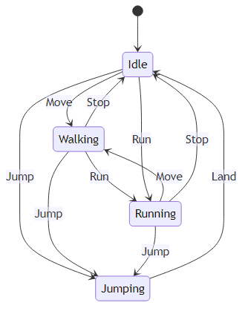
Note: loop transitions are not shown in the diagram for simplicity.
Solution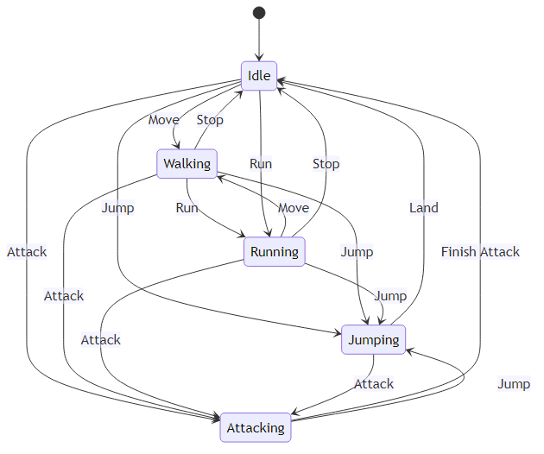

Part II - Write Code
Your task is to complete the AttackingState class in Code Snippet B. The remaining classes have already been implemented and are provided and you may look into them as a hint.
To aid your understanding of Code Snippet B, a UML diagram is also included.
You Answer:
class AttackingState(CharacterState):
def move(self, character):
print("Character cannot walk while attacking.")
def run(self, character):
print("Character cannot run while attacking.")
def jump(self, character):
print("Character starts attacking mid-air.")
character.change_state(JumpingState())
def attack(self, character):
print("Character is already attacking.")
def stop(self, character):
print("Character cannot stop while attacking.")
def finish_attack(self, character):
print("Character finishes the attack.")
character.change_state(IdleState())

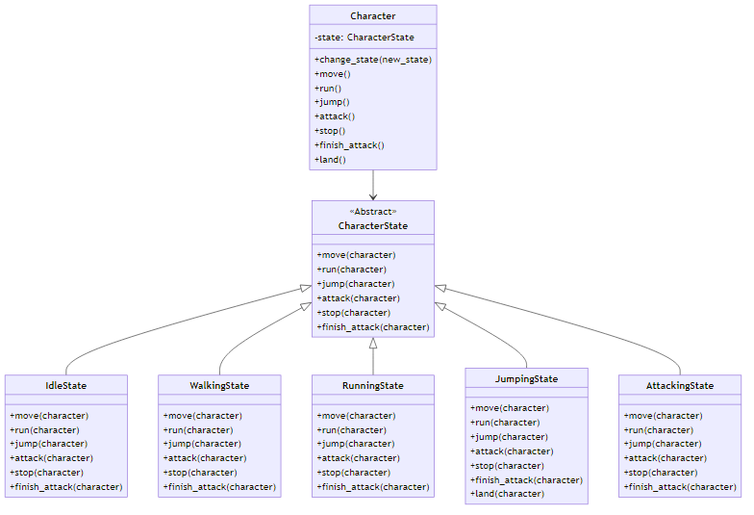

Code Snippet A
class Character:
def __init__(self):
self.state = "Idle"
def move(self):
if self.state == "Idle":
print("Character starts walking.")
self.state = "Walking"
elif self.state == "Walking":
print("Character is already walking.")
elif self.state == "Running":
print("Character slows down to walk.")
self.state = "Walking"
elif self.state in ["Jumping", "Attacking"]:
print("Character cannot walk while", self.state.lower() + ".")
def run(self):
if self.state == "Idle":
print("Character starts running.")
self.state = "Running"
elif self.state == "Walking":
print("Character starts running.")
self.state = "Running"
elif self.state == "Running":
print("Character is already running.")
elif self.state in ["Jumping", "Attacking"]:
print("Character cannot run while", self.state.lower() + ".")
def jump(self):
if self.state in ["Idle", "Walking", "Running"]:
print(
f"Character jumps while {self.state.lower()}." if self.state != "Idle" else "Character jumps.")
self.state = "Jumping"
elif self.state == "Jumping":
print("Character is already jumping.")
elif self.state == "Attacking":
print("Character starts attacking mid-air.")
self.state = "Jumping"
def attack(self):
if self.state in ["Idle", "Walking", "Running"]:
print(f"Character starts attacking while {self.state.lower()}.")
self.state = "Attacking"
elif self.state == "Jumping":
print("Character starts attacking mid-air.")
self.state = "Attacking"
elif self.state == "Attacking":
print("Character is already attacking.")
def stop(self):
if self.state == "Idle":
print("Character is already idle.")
elif self.state == "Walking":
print("Character stops walking.")
self.state = "Idle"
elif self.state == "Running":
print("Character stops running.")
self.state = "Idle"
elif self.state in ["Jumping", "Attacking"]:
print("Character cannot stop while", self.state.lower() + ".")
def finish_attack(self):
if self.state == "Attacking":
print("Character finishes the attack.")
self.state = "Idle"
else:
print("Character is not attacking.")
def land(self):
if self.state == "Jumping":
print("Character lands on the ground.")
self.state = "Idle"
else:
print("Character is not jumping.")
if __name__ == "__main__":
character = Character()
# Character transitions
character.move() # Idle -> Walking
character.run() # Walking -> Running
character.jump() # Running -> Jumping
character.land() # Jumping -> Idle
character.attack() # Idle -> Attacking
character.finish_attack() # Attacking -> Idle

Code Snippet B
from abc import ABC, abstractmethod
class CharacterState(ABC):
@abstractmethod
def move(self, character):
pass
@abstractmethod
def run(self, character):
pass
@abstractmethod
def jump(self, character):
pass
@abstractmethod
def attack(self, character):
pass
@abstractmethod
def stop(self, character):
pass
@abstractmethod
def finish_attack(self, character):
pass
class IdleState(CharacterState):
def move(self, character):
print("Character starts walking.")
character.change_state(WalkingState())
def run(self, character):
print("Character starts running.")
character.change_state(RunningState())
def jump(self, character):
print("Character jumps.")
character.change_state(JumpingState())
def attack(self, character):
print("Character starts attacking.")
character.change_state(AttackingState())
def stop(self, character):
print("Character is already idle.")
def finish_attack(self, character):
print("Character is not attacking.")
class WalkingState(CharacterState):
def move(self, character):
print("Character is already walking.")
def run(self, character):
print("Character starts running.")
character.change_state(RunningState())
def jump(self, character):
print("Character jumps while walking.")
character.change_state(JumpingState())
def attack(self, character):
print("Character starts attacking while walking.")
character.change_state(AttackingState())
def stop(self, character):
print("Character stops walking.")
character.change_state(IdleState())
def finish_attack(self, character):
print("Character is not attacking.")
class RunningState(CharacterState):
def move(self, character):
print("Character slows down to walk.")
character.change_state(WalkingState())
def run(self, character):
print("Character is already running.")
def jump(self, character):
print("Character jumps while running.")
character.change_state(JumpingState())
def attack(self, character):
print("Character starts attacking while running.")
character.change_state(AttackingState())
def stop(self, character):
print("Character stops running.")
character.change_state(IdleState())
def finish_attack(self, character):
print("Character is not attacking.")
class JumpingState(CharacterState):
def move(self, character):
print("Character cannot walk while jumping.")
def run(self, character):
print("Character cannot run while jumping.")
def jump(self, character):
print("Character is already jumping.")
def attack(self, character):
print("Character starts attacking mid-air.")
character.change_state(AttackingState())
def stop(self, character):
print("Character cannot stop mid-air.")
def finish_attack(self, character):
print("Character is not attacking.")
def land(self, character):
print("Character lands on the ground.")
character.change_state(IdleState())
class AttackingState(CharacterState):
pass
# TODO
class Character:
def __init__(self):
self.state = IdleState()
def change_state(self, new_state):
self.state = new_state
def move(self):
self.state.move(self)
def run(self):
self.state.run(self)
def jump(self):
self.state.jump(self)
def attack(self):
self.state.attack(self)
def stop(self):
self.state.stop(self)
def finish_attack(self):
self.state.finish_attack(self)
def land(self):
if isinstance(self.state, JumpingState):
self.state.land(self)
else:
print("Character is not jumping.")
if __name__ == "__main__":
character = Character()
# Character transitions
character.move() # Idle -> Walking
character.run() # Walking -> Running
character.jump() # Running -> Jumping
character.land() # Jumping -> Idle
character.attack() # Idle -> Attacking
character.finish_attack() # Attacking -> Idle

The End.

